

ST MARYS

SENIOR

HIGH SCHOOL

**YEAR 11**

**YEARLY EXAMINATION**

**2018**

|  |  |
| --- | --- |
| Physics Table Number: ........................ Candidate Number: .............................................  Teacher: .......................................................... Line: ........................ Booklet 1General Instructions  * Reading time – 5 minutes * Working time – 2 hours * Write using black pen * Draw diagrams using pencil * NESA approved calculators may be used * Write your student and table number on  each booklet | Total marks – *75* This paper has two parts, Part A and Part B  Part A – 20 marks   * Attempt Questions 1-20 * Allow about 35 minutes for this part   Part B – 50 marks   * Attempt Questions 21-34 * Consists of 3 booklets * Allow about 1 hour 25 minutes for this part |

**Section I – 20 marks**

**Attempt Questions 1-20**

**Allow about 35 minutes for this section**

Use the multiple-choice answer sheet.

Select the alternative A, B, C or D that best answers the question. Fill in the response oval completely.

Sample: 2 + 4 = (A) 2 (B) 6 (C) 8 (D) 9

A B C D

If you think you have made a mistake, put a cross through the incorrect answer and fill in the new answer.

A B C D

If you change your mind and have crossed out what you consider to be the correct answer, then indicate the correct answer by writing the word **correct** and drawing an arrow as follows.

A B C D

**correct**

**1.** A car moving down a straight road has its motion analysed and plotted on a graph, shown below.

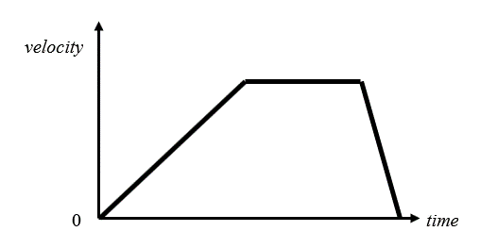

Which description most accurately describes the car’s motion?

1. The car travels at a steady speed, stops for a while and then returns to where

It started.

(B) The car starts from rest, accelerates, continues with constant speed and then rapidly slows down to a stop.

(C) The car’s acceleration increases until it reaches a certain speed when it stops for a while and then accelerates backwards until it stops.

(D) The car travels at a steady speed, stops, and then returns to where it started.

**2.** Which are all vector quantities?

(A) displacement, acceleration, mass, weight

(B) force, speed, acceleration, time

(C) time, force, velocity, acceleration

(D) displacement, force, acceleration, weight

**3.** A wave that requires a medium to propagate through is:

(A) light.

(B) electromagnetic radiation.

(C) a mechanical wave.

(D) a transverse wave.

**4.** Select the balance that would correctly measure mass of an object on both the Earth and the Moon where the acceleration due to gravity is 1.6m.s-2.

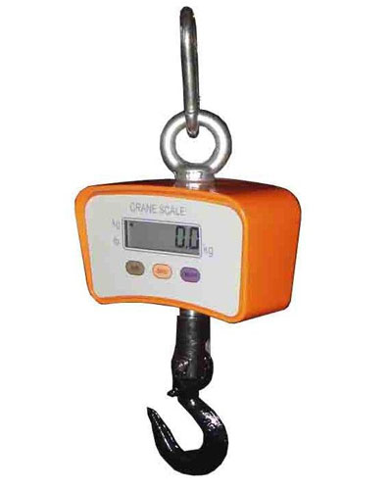

1. (B)



(C) 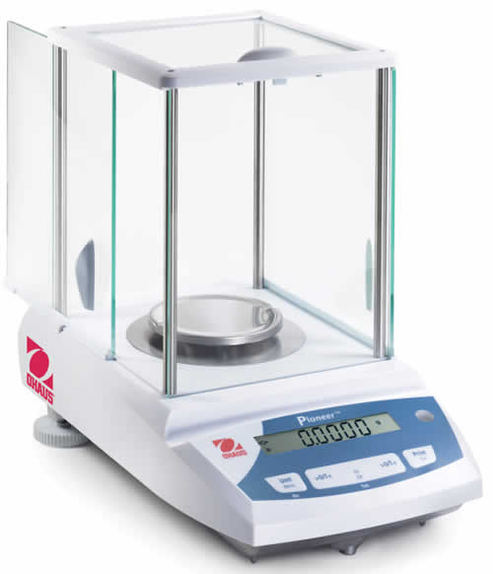 (D)

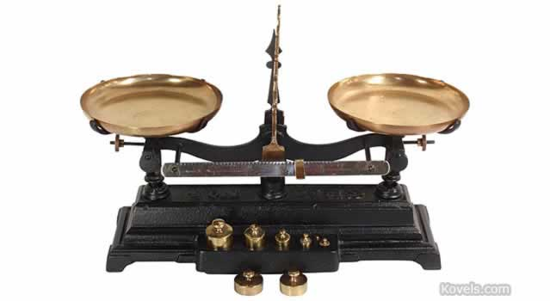

**5.** A yellow car accelerates from rest at 3.5m.s -2 East for 10.0 s.

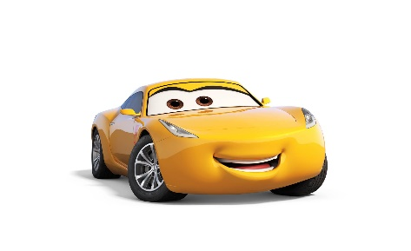

How far would the car have travelled in this time?

(A) 17.5m East

(B) 35.0m East

(C) 35.0 m.s -1 East

(D) 175 m East

**6.** A white car is travelling north at 25 m s-1. A blue car is travelling west at 20 m s-1.

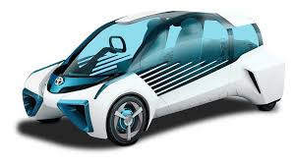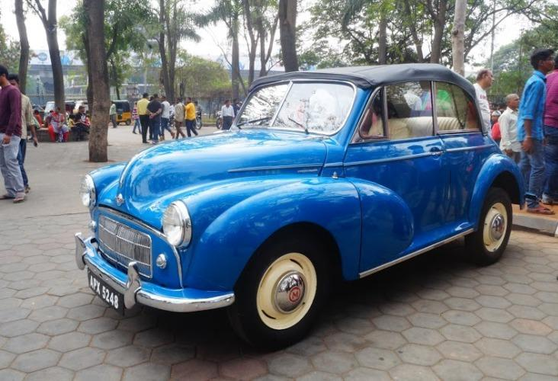

Which vector best represents the velocity of the blue car relative to the white car?

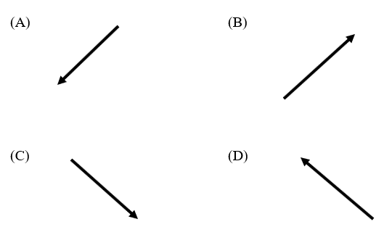

**7.** The straight-line distance between two towns, A and B, is 240 km. The road that connects the towns is 320 km long. Town B is ENE of town A.

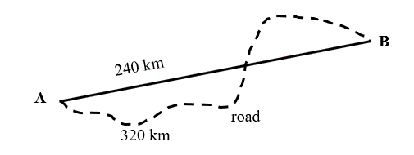

A car drives from town A to town B, taking 4 hours exactly.

Which alternative is correct?

|  |  |  |
| --- | --- | --- |
|  | Average speed of car  (km h-1) | Average velocity of car  (km h-1) |
| (A) | 80 | 60 ENE |
| (B) | 80 ENE | 60 |
| (C) | 60 | 80 ENE |
| (D) | 80 | 80 ENE |

**8.** Cutting a magnet in half always produces two magnets with opposite poles. Which of the following can be deduced from this information, in relation to the poles of a magnet?

(A) magnets can easily be cut in half

(B) all magnets are dipolar

(C) when magnets are cut the poles split in half

(D) all split magnets are monopolar

**9.** Captain Jack McClure’s rocket powered go-kart could accelerate from rest to 90m.s ‑1 in a distance of 305 m.

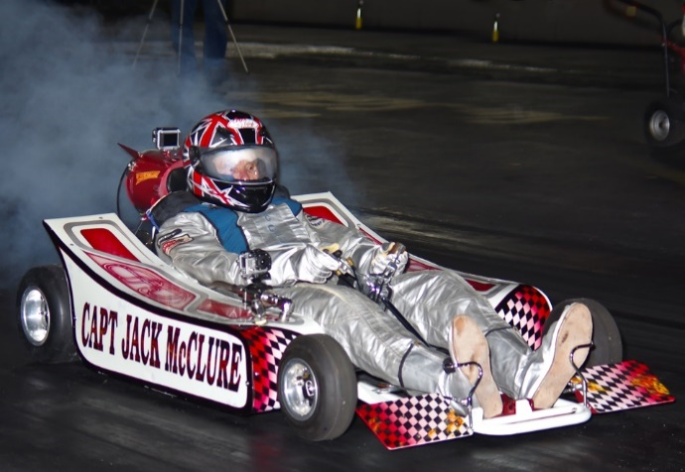

What was his average acceleration during this time?

(A) 6.78 s

(B) 13.3 m.s -2

(C) 9.8 m.s -2

(D) 45.8 m.s -2

**10.** A system as shown below is set up in a school laboratory.

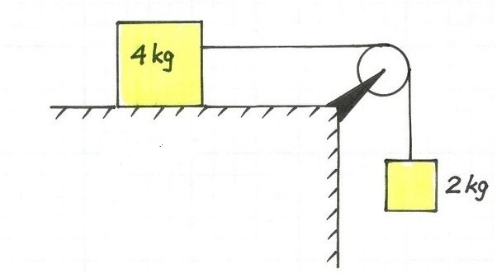

If friction is negligible, find the acceleration of the system

(A) 3.3 m.s -2

(B) 6.6 m.s -2

(C) 9.8 m.s -2

(D) 58.8 m.s -2

**11.** A golf ball is struck and given an initial speed of 40.0 m s-1 at an angle 30° above the horizontal.

Which expression gives the golf ball’s initial vertical component of its velocity?

(A) 30 sin40°

(B) 40.0 cos30°

(C) 40.0 sin30°

(D) 40.0 tan30°

**12.** The forces on an aircraft flying 10 km above the ground are shown in the diagram.

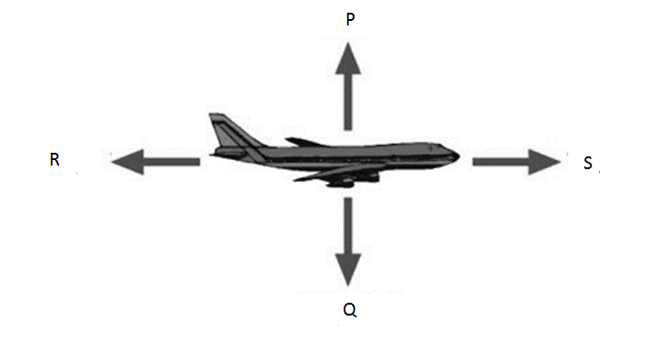

The magnitude of Force P = the magnitude of Force Q.

The magnitude of Force R = the magnitude of Force S

By referring only to the diagram, which statement could NOT be correct?

(A) The aircraft is motionless in the sky.

(B) The aircraft is descending at a constant rate.

(C) The aircraft’s speed is increasing.

(D) The aircraft is flying at a constant velocity.

**13.** Two men firing duelling pistols have the unusual event where the bullets collide and stop midway between the opponents.

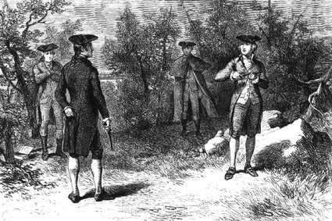

If the gentleman in black fired a bullet with a mass of 5.2g and a velocity of 440ms‑1 his opponent bullets mass and velocity is closest to:

(A) 2288 Ns

(B) 5.65g and 400 ms-1

(C) 4.53g and 505 ms-1

(D) 3.1g and 750 ms-1

**14.** If the gentleman in black had a bullet with a mass of 5.2g with a velocity of 440ms‑1 its kinetic energy is closest to:

:

(A) 1.14 J

(B) 503.4 J

(C) 503360 J

(D) 1006720 J

**15.** In performing an investigation, a large number of measurements of the dependent variable were taken. Three separate teams performed the same investigation.

Which team’s results were the least reliable?

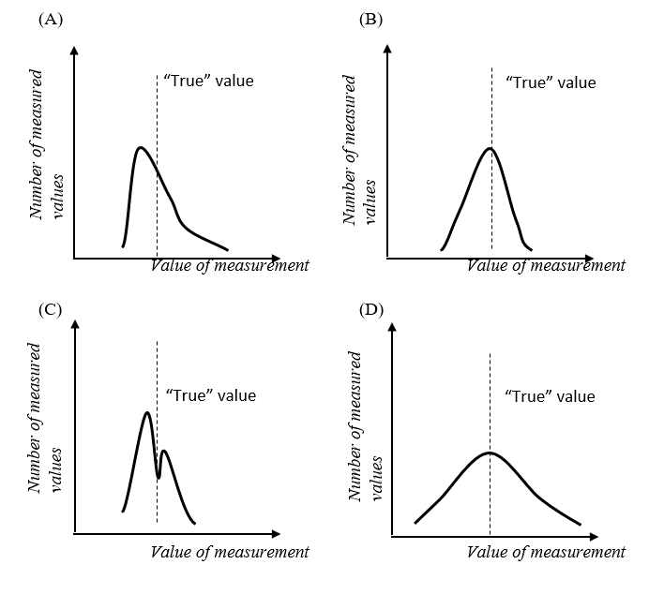

**16.** A 10.0 kg bird is sitting on a massless wire mid-way between two poles, as shown.

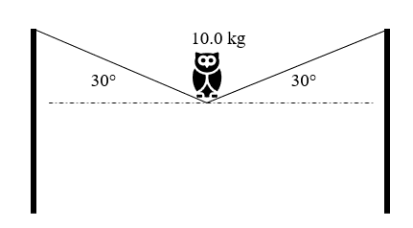

The tension in the wire is closest to:

(A) 49 N

(B) 98 N

(C) 196 N

(D) 226 N

**17.** A bicycle rider exerts a forwards force of 200 N through the pedals of the bike when riding on a horizontal surface.

The masses of the bike and the rider total 85 kg.

The acceleration produced by this force is 2.0 m s-2.

From this information, it can be concluded that:

(A) there was no friction force acting at this time.

(B) the wind was blowing against the bicycle.

(C) Newton’s 2nd law of motion was not applicable to this motion.

(D) the sum of the friction forces acting is 30 N.

**18.** A crane uses a 5.0 kW motor to lift a mass of 200 kg from the ground to a height of 40.0 m.

Assuming the motor is 100% efficient, how long would it take the crane to perform this task?

(A) 16 s

(B) 16000 s

(C) 32 s

(D) 78 s

**19.** A 10 kg rock is dropped from rest and falls vertically for 5.0 s. After this time, the rock was moving at 40.0 m s-1. What was the work done against air friction in this time?

(A) 12 kJ

(B) 4 kJ

(C) 9 kJ

(D) 100 J

**20.** Which of the following labels best describes the waves amplitude?

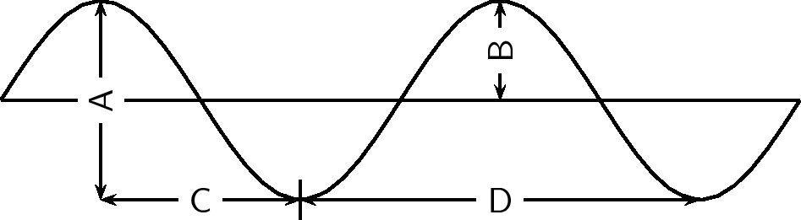

Table Number: ..................

Candidate Number: ....................................

Teacher: ........................................................



**2018**

**YEARLY EXAMINATION**

ST MARYS

SENIOR

HIGH SCHOOL

**Part B – 55 marks**

**Attempt Questions 21 - 34**

* Answer the questions in the spaces provided.
* These spaces provide guidance for the expected length of response.
* Show all relevant working in questions involving calculations
* Spare paper is also available upon request. If you use this space, clearly indicate which question you are answering. Also indicate in the question space to refer to that page.

**Booklet 1 – Questions 21-24**

For teacher use only

|  |  |  |  |  |  |  |  |  |  |
| --- | --- | --- | --- | --- | --- | --- | --- | --- | --- |
| 21a | 21b | 21c | 22a | 22b | 23a | 23b | 24a | 24b | Total |
| /2 | /2 | /1 | /2 | /2 | /2 | /2 | /2 | /2 | /17 |

|  |  |
| --- | --- |
| **Question 21** (5 marks)  A small trolley moves past a point with a speed of 1.6 m s-1. It is moving on a horizontal surface and slows to a stop in 8.0 s.  (a) Describe the forces acting on the trolley as it is slowing down, by drawing  labelled arrows on the diagram above.  **Question 21 continues on page 14**  Question 21 (continued)  (b) Calculate the acceleration of the trolley as it is slowing down.  ……………………………………………………………………………………………..…………………………...  …………………………………………………………………………………………...........……………………...  …………………………………………………………………………………………………………………………...  ……………………………………………………………………………………………………………………….…...  (c) Identify another quantity which would need to be measured so that the  net force acting on the trolley could be found.  …………………………………………………………………………………………………………………………...  ………………………………………………………………………………………….……………………………….. | **Marks**  **2**  **2**  **1** |

|  |  |
| --- | --- |
| **Question 22** (4 marks)  (a) Describe the role played by friction when a car accelerates, moves around a  corner and stops.  ……………………………………………………………………………………………..…………………………...  …………………………………………………………………………………………...........……………………...  ……………………………………………………………………………………………..…………………………...  …………………………………………………………………………………………...........……………………...  (b) A 1200 kg car has a coefficient of static friction between the tyres and the  ground of 0.75. Find the maximum acceleration for this car.  ……………………………………………………………………………………………..…………………………...  …………………………………………………………………………………………...........……………………...  …………………………………………………………………………………………………………………………...  ……………………………………………………………………………………………………………………….…...  **Question 23** (4 marks)  Two cars collide head-on, as shown in the diagram.  (a) When the cars collide they become entangled. Show that the combined  wreckage is stationary immediately after the collision.  ……………………………………………………………………………………………..…………………………...  …………………………………………………………………………………………...........……………………...  …………………………………………………………………………………………………………………………...  ……………………………………………………………………………………………………………………….…...  (b) Explain why the collision is inelastic, using equations where appropriate.  ……………………………………………………………………………………………..…………………………...  …………………………………………………………………………………………...........……………………...  …………………………………………………………………………………………………………………………...  ……………………………………………………………………………………………………………………….…...  …………………………………………………………………………………………………………………………….  **Question 24** (4 marks)  (a) Label and then use the axes below to sketch and label a wave with an  amplitude of 2 cm and a frequency of 0.50 Hz.  (b) Two shipwrecked sailors are floating in the middle of the ocean. They  observe long ocean waves passing beneath the life raft.  Outline how the sailors could calculate the speed of these ocean waves by  making simple observations which do not include measuring the speed of  the waves directly.  ……………………………………………………………………………………………..…………………………...  …………………………………………………………………………………………...........……………………...  …………………………………………………………………………………………………………………………...  ……………………………………………………………………………………………………………………….…... | **Marks**  **2**  **2**  **Marks**  **2**  **2**  **Marks**  **2**  **2** |



**2018**

**YEARLY EXAMINATION**

Table Number: ..................

Candidate Number: ....................................

Teacher: ........................................................

ST MARYS

SENIOR

HIGH SCHOOL

**Booklet 2 – Questions 25-29**

For teacher use only

|  |  |  |  |  |  |  |  |  |
| --- | --- | --- | --- | --- | --- | --- | --- | --- |
| 25a | 25b | 26a | 26b | 27 | 28a | 28b | 29 | Total |
| /1 | /2 | /2 | /2 | /4 | /2 | /2 | /4 | /12 |

|  |  |
| --- | --- |
| **Question 25** (3 marks)  Fig. 1 shows a long rope that is tied at one end to a high support. A woman swings forwards and backwards across a pool using the other end of the rope.    **Question 25 continues on page 18**  Question 25 (continued)  Fig. 2 shows the variation with time *t* of the displacement *x*, of the woman from **A** to **B** and back to **A**.     1. Identify what the gradient of the graph represents   …………………………………………………………………………………………………………………………...   1. Explain why the graph shows both positive and negative gradients   ……………………………………………………………………………………………..…………………………...  …………………………………………………………………………………………...........……………………...  …………………………………………………………………………………………………………………………...  ……………………………………………………………………………………………………………………….…...  **Question 26** (4 marks)  An old grandfather clock made in 1830 uses gravitational potential energy to run. A 6.00kg mass falls through 1.12 metres in 7.3 days.     1. Calculate the Energy stored in the clock when the mass 6.0kg has been raised to its highest point 1.12m above its lowest?   ……………………………………………………………………………………………..…………………………...  …………………………………………………………………………………………...........……………………...  …………………………………………………………………………………………………………………………...  ……………………………………………………………………………………………………………………….…...  (b) If this Energy runs the clock for 7.3 days calculate the power of the clock?  ……………………………………………………………………………………………..…………………………...  …………………………………………………………………………………………...........……………………...  …………………………………………………………………………………………………………………………...  ……………………………………………………………………………………………………………………….…... | **Marks**  **Marks**  **1**  **2**  **Marks**  **2**  **2** |
| **Question 27** (4 marks)  With the use of diagrams, explain the difference between constructive and destructive interference of waves.  ……………………………………………………………………………………………..…………………………...  …………………………………………………………………………………………...........……………………...  …………………………………………………………………………………………………………………………...  ……………………………………………………………………………………………………………………….…...  ……………………………………………………………………………………………..…………………………...  …………………………………………………………………………………………...........……………………...  …………………………………………………………………………………………………………………………...  ……………………………………………………………………………………………………………………….…...  ……………………………………………………………………………………………..…………………………...  …………………………………………………………………………………………...........……………………...  …………………………………………………………………………………………………………………………...  ……………………………………………………………………………………………………………………….…... | **Marks**  **4** |

|  |  |
| --- | --- |
| **Question 28** (4 marks)  A flea jumps vertically from a surface. It does this by rapidly extending its legs so that it experiences an upward force. Figure 1 shows the flea before it begins its jump. Figure 2 shows the flea the moment its legs are fully extended and about to leave the surface.  **Question 28 continues on page 21**  Question 28 (continued)  (a) Explain how Newton’s third law accounts for the upward force produced.  ……………………………………………………………………………………………..…………………………...  …………………………………………………………………………………………...........……………………...  …………………………………………………………………………………………………………………………...  ……………………………………………………………………………………………………………………….…..  ……………………………………………………………………………………………..…………………………...   1. At the moment the flea’s legs leave the surface its body is raised 0.44 mm and it is moving at a speed of 0.95 m s–1. Show that the average acceleration of the flea during take-off is about 1000 m s–2.   ……………………………………………………………………………………………..…………………………...  …………………………………………………………………………………………...........……………………...  …………………………………………………………………………………………………………………………...  ……………………………………………………………………………………………………………………….…..  ……………………………………………………………………………………………………………………….…..  ……………………………………………………………………………………………………………………….….. | **Marks**  **2**  **2** |

|  |  |
| --- | --- |
| **Question 29** (4 marks)  Using a diagram, describe the forces that occur between like and opposite poles in a pair of magnets  ……………………………………………………………………………………………..…………………………...  …………………………………………………………………………………………...........……………………...  …………………………………………………………………………………………………………………………...  ……………………………………………………………………………………………………………………….…...  ……………………………………………………………………………………………..…………………………...  …………………………………………………………………………………………...........……………………...  …………………………………………………………………………………………………………………………...  ……………………………………………………………………………………………………………………….….. | **Marks**  **4** |

BLANK PAGE



**2018**

**YEARLY EXAMINATION**

Table Number: ..................

Candidate Number: ....................................

Teacher: ........................................................

ST MARYS

SENIOR

HIGH SCHOOL

**Booklet 3 – Questions 30-34**

For teacher use only

|  |  |  |  |  |  |  |  |  |  |  |  |
| --- | --- | --- | --- | --- | --- | --- | --- | --- | --- | --- | --- |
| 30a | 30b | 31a | 31b | 31c | 31d | 32a | 32b | 33 | 34a | 34b | Total |
| /1 | /2 | /4 | /3 | /2 | /1 | /2 | /2 | /2 | /2 | /1 | /19 |

|  |  |
| --- | --- |
| **Question 30** (3 marks)  In an expresso coffee machine steam at 100°C is passed into milk to heat the milk  (a) calculate the energy required to heat 150g of milk from 20°C to 80°C (cmilk = 4010 J kg K-1)  ……………………………………………………………………………………………..…………………………...  …………………………………………………………………………………………...........……………………...  …………………………………………………………………………………………………………………………...  ……………………………………………………………………………………………………………………….…..  ……………………………………………………………………………………………………………………….…..   1. identify one assumption that you made in completing this calculation   ……………………………………………………………………………………………..…………………………...  …………………………………………………………………………………………...........……………………... | **Marks**  **2**  **1** |

|  |  |
| --- | --- |
| **Question 31** (7 marks)  Two students, Sam and Alex, propose to have a race using their small aircraft, both of which can fly through still air at the same speed, 140 km h-1. They will both start and finish at the same point, but they will fly to different points, **A** and **B**, which are 90° apart and both 100 km from the start.  They will then turn around and come back to the finish. The distance they will race is the same, but a steady wind blows from the east at 40 km h-1 throughout the race.  The details are shown on a map below.  (a) Calculate how long it takes Sam to fly to point **B** and fly back to the finish.  ……………………………………………………………………………………………..…………………………...  …………………………………………………………………………………………...........……………………...  …………………………………………………………………………………………………………………………...  ……………………………………………………………………………………………………………………….…..  ……………………………………………………………………………………………………………………….…..  **Question 31 continues on page 27**  Question 31 (continued)  (b) Using a diagram, find the direction that Alex will need to head so that the  plane travels directly north over the ground.  (c) Find the time it takes Alex to fly to point **A** and back to the finish.  ……………………………………………………………………………………………..…………………………...  …………………………………………………………………………………………...........……………………...  …………………………………………………………………………………………………………………………...  ……………………………………………………………………………………………………………………….…..  ……………………………………………………………………………………………………………………….…..  (d) Predict the outcome of the race if the wind was blowing from the east at  140 km h-1.  ……………………………………………………………………………………………..…………………………...  …………………………………………………………………………………………...........……………………...  …………………………………………………………………………………………………………………………...  ……………………………………………………………………………………………………………………….… | **Marks**  **2**  **Marks**  **2**  **2**  **1** |

|  |  |
| --- | --- |
| **Question 32** (4 marks)  During the Year 11 Physics course, many first-hand investigations were undertaken where there were elements of risk involved.  (a) Identify one such investigation and state *two* risks relevant to that  investigation and the control measures taken for each risk to ensure your  safety and the safety of others.  ……………………………………………………………………………………………..…………………………...  …………………………………………………………………………………………...........……………………...  …………………………………………………………………………………………………………………………...  ……………………………………………………………………………………………………………………….…..  ……………………………………………………………………………………………………………………….…..   1. Describe how you would ensure that the results of a first-hand   investigation would be reliable.  ……………………………………………………………………………………………..…………………………...  …………………………………………………………………………………………...........……………………...  …………………………………………………………………………………………………………………………...  ……………………………………………………………………………………………………………………….…..  ……………………………………………………………………………………………………………………….…..  **Question 33** (2 marks)  Outline an advantage and a disadvantage of using models to explain scientific ideas.  ……………………………………………………………………………………………..…………………………...  …………………………………………………………………………………………...........……………………...  …………………………………………………………………………………………………………………………...  ……………………………………………………………………………………………………………………….….. | **Marks**  **2**  **2**  **2** |
| **Question 34** (3 marks)   1. When collecting the results of a first-hand investigation, a student plots   the data on a graph and then draws a line of best fit.  Explain why this might be done rather than to join each data point.  ……………………………………………………………………………………………..…………………………...  …………………………………………………………………………………………...........……………………...  …………………………………………………………………………………………………………………………...  ……………………………………………………………………………………………………………………….…..  ……………………………………………………………………………………………………………………….…..  (b) The distance between the Earth and the moon is 380 000 000 m. Express this value using scientific notation  ……………………………………………………………………………….……………………...  BLANK PAGE | **Marks**  **2**  **1** |

BLANK PAGE